Setting up equations:
The rules for setting an equation are:
- The value that is not known or to be found is assigned a variable.
- Then the expressions are formed as per the conditions given in the question.
- Finally, the expressions are equated with values given in the question.
Example
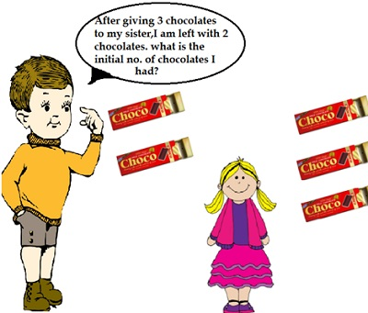
The value that is not known or to be found is assigned a variable.
Let the number of chocolates that the boy initially had =x
Then the expressions are formed as per the conditions given in the question.
Number of chocolates given to the sister =2
Number of chocolates that the boy is left with = 2(given)
Number of chocolates that the boy is left with = Initial of number chocolates he had – no of chocolates given to the girl = x-2 =2
Finally, the expressions are equated with values given in the question.
Number of chocolates that the boy is left with:
x-3 =2
Therefore, the equation set up is x-3 = 2.
Problem Write equations for the following statements:
(i)Laxmi’s father is 49 years old. He is 4 years older than three times Laxmi’s age. (Take Laxmi’s age to be y years.)
The value that is not known or to be found is assigned a variable.
Let the age of Laxmi=y years
Then the expressions are formed as per the conditions given in the question.
Laxmi’s father age = 49
Laxmi’s father’s is 4 years older than three times Laxmi’s age
Laxmi’s fathers age = 4+3y
Finally, the expressions are equated with values given in the question.
4 + 3y =49
Therefore, the equation set up is 4+3y =49.

